**Step 1:**Unlock your mobile device and connect it to your computer using USB cable

**Step 2:**Open Command Prompt and run **‘adb devices’**command. We are running this command to just make sure that your mobile is properly connected.

**Step 3:**Once you run **‘adb devices’** command, you should see that it displays the list of attached devices as shown in the below image (the actual device name that you see would be different based on what mobile phone you use) –

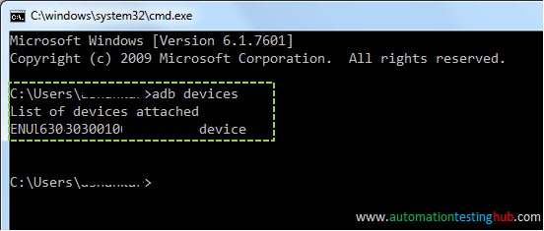

**Step 4:**Run **‘adb shell’** command. After running this command, the command prompt should look something like this –

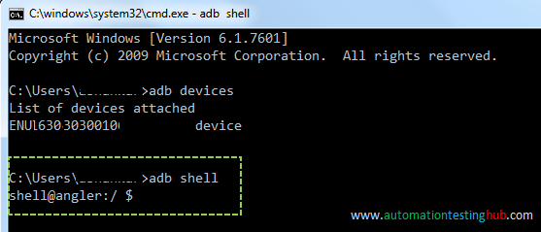

**Step 5: Now in your mobile phone, open the app for which you want to find the appPackage and appActivity.** Since we are doing this for Play Store, hence we will open **“Play Store”** on our mobile phone.

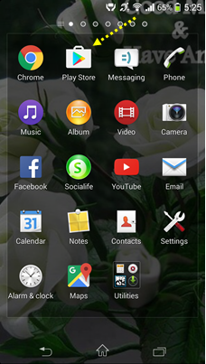

**Note:** Please make sure that you open the app before going to the next step, because command in the next step would provide the details only for the app which is currently in focus.

**Step 6:**Now run this command: **dumpsys window windows | grep -E ‘mCurrentFocus’**

**Step 7:**The above command would display the details of the app which is currently in focus. From that, you can figure out the appPackage and appActivity name as per the below image –

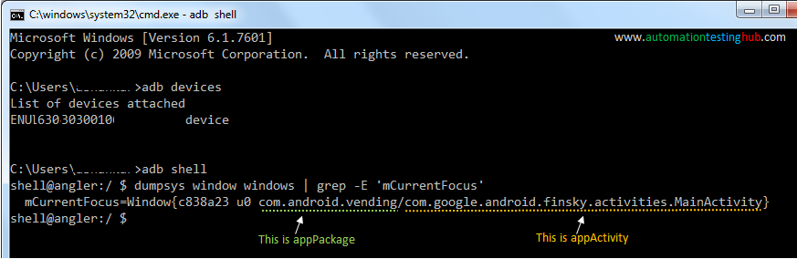

appPackage starts with com. and ends before backshash (/). So from the above image, appPackage name is – **com.android.vending**

appActivity starts after the backslash (/) and goes till the end. From the above image, appActivity name is – **com.google.android.finsky.activities.MainActivity**

**Step 8:**There is one more similar command that provides the appPackage and appActivity name. This command adds some additional details before and after the package name & activity name, but you can still try it out just to verify that the results from the above command are same. This command is – **dumpsys window windows | grep -E ‘mFocusedApp’**and the output of this command is shown below –

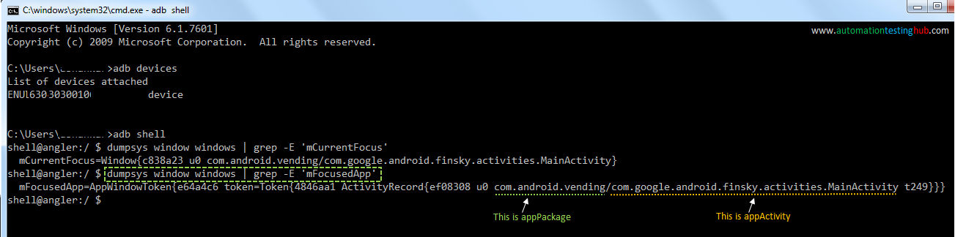

This completes our first method of identifying appPackage and appActivity name. However, there is one important point which you should keep in mind. For some apps, the appActivity name would shown as relative name in command prompt, i.e., it would not start with com. In such cases, you would need to add com…. at the beginning on your own.

**For example,** consider some app which shows **com.myapp/.mainActivity** in command prompt when you run the above commands. In this case, you will notice that the appActivity starts with a dot (which is a relative name). So you would need to add com… at the beginning. After adding the complete appActivity name that you will use would be – **com.myapp.mainActivity**